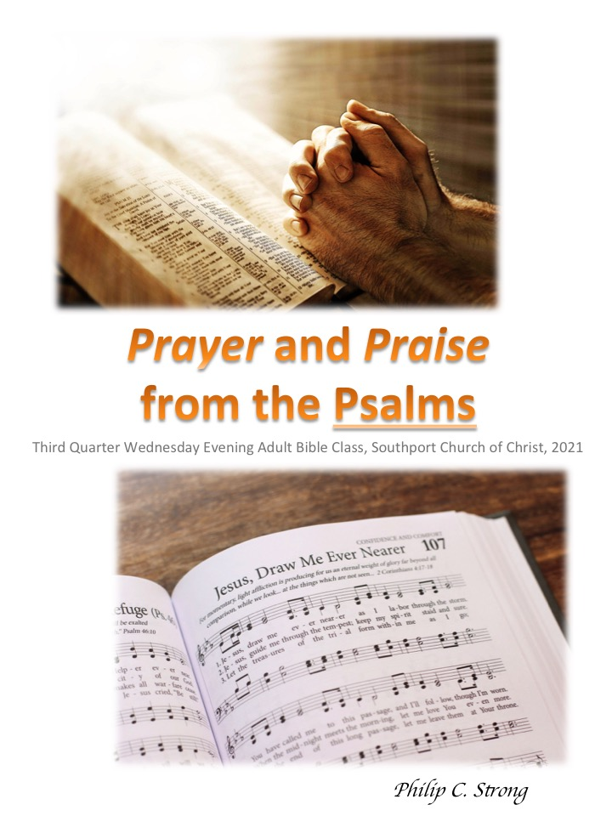
Preface to Prayers and Praise from the Psalms:
Understanding Prayer Generally
- What verse(s) do you think best defines prayer?
- Matt.6:9-13. How would classify or describe each part of this model prayer:
- v.9?
- v.10?
- v.11?
- v.12?
- v.13?
- 1Tim.2:1 identifies four elements types of prayers:
- Entreaties (supplications, KJV): deesis- want, need, penury, privation; seeking, asking, cf. Rom.10:1; 1Tim.5:5; Jas.5:16;
- Prayers: prosuche- prayer or a place of prayer, cf. Matt.21:13,22; Rom.12:12;
- Petitions (intercessions, KJV): enteuxis- to fall in with; converse or for any other cause, cf. 1Tim.4:5 (enteuxis is only found in 1Tim.2:1 and 4:5, though the verb form, entynchano {intercede), is found also in other passages such as Rom.8:27,34; Heb.7:25); and,
- Thanksgivings: eucharista- the giving of thanks, cf. Matt.26:27 (different form of same root); 1Cor.14:16; Phil.4:6.
- Which of these elements/aspects are most common in our prayers (especially the public ones)? Why do you think this is so?
- What other types of prayers can you name (if possible, provide a biblical example of that type of prayer)?
Lesson 1- Introduction, Prayers and Praise from the Psalms
I. Why prayers instead of psalms?
- Many of the “psalms” are prayers (more on this later).
- It is much more difficult to compose and sing a psalm, even if we utilize inspired words, than it is to compose and offer a prayer. But,
- Our prayers, much like our singing, can easily become rote recitations rather than sincere expressions of our true heart’s desire, cp. Matt.6:7 and Rom.10:1. Therefore,
- Our prayers and praise, especially our public ones, even with the intercession of the Spirit, cf. Rom.8:26, could typically be enhanced by greater understanding and more emotion (heart)… and the better expression of both.
II. Differences between Hebrew and Western poetry:
- Western (as related to the globe, not cowboys) poetry utilizes primarily rhyme and meter.
- Hebrew poetry is much more centered on rhythm and parallelism (the use of successive verbal constructions in poetry or prose which correspond in grammatical structure, sound, meter, meaning, etc.).
III. Organization of the Psalms. There are five distinct Books- each one has its own doxology at the end (Book 5 has an entire psalm which serves as its doxology).
- Book 1, Psalms 1 – 41
- Book 2, Psalms 42 – 72
- Book 3, Psalms 73 – 89
- Book 4, Psalms 90 – 106
- Book 5, Psalms 107 – 150
IV. Writers of the Psalms:
- David, with no fewer than 73 attributed to him;
- Asaph (50; 73 – 83)
- Sons of Korah, (42 – 49; 84 – 85; 87 – 88)
- Solomon, (72; 127)
- Heman, (88)
- Ethan, (89)
- Ezrahites and Moses, (90)
V. Possible explanations of repeated but largely unidentified terms and expressions:
- Selah, may imply a pause (even as a sigh) or an interlude;
- Maskil, possibly indicating a contemplative, didactic, or skillful (making one wise or spiritually skillful); cf. Ps.32; 42; 44 – 45; 52 – 55; 74; 78; 88 – 89; 142;
- Miktam, perhaps an epigrammatic (pithy or short) poem; or a psalm of lament, a plea for atonement, or plea for protection- a spiritual SOS; cf. Ps.16; 56 – 60; and,
- Sheol, can refer either to death/the grave or the nether world (realm or state of the dead).
VI. Why prayer when “psalms” refers to songs?
Perhaps this quote will help to explain: “The marrow of the religious life of the psalmists was undoubtedly their knowledge of God. They never tire of singing his majesty in creation. In all his works in the heavens, the earth and the sea he has made himself known as the all-powerful, the all-knowing, the everywhere-present God. He is also the God of all history who guides everything towards the final goal which he has purposed to fulfil. But this Ruler of the world, this King of kings, is also Lawgiver and Judge, the Vindicator of all who are oppressed and their Saviour. He is therefore merciful and faithful, just and righteous, the Holy One whom men and angels adore. But the God of the psalmists is also, and uniquely, the God of Israel. The God who revealed himself to Abraham, Isaac and Jacob, who through Moses delivered Israel from Egypt, entered into covenant with them and gave them the promised land, is the God of Israel still, the Lord and Defender of the chosen people.
With such a high conception of God it is not surprising that the psalmists found their chief delight and privilege in prayer to God. There is a directness, a spontaneity and an immediacy in the prayers of the psalmists that convince us of the reality of prayer for them. They believe in his providence, trust in his presence, rejoice in his righteousness, rest in his faithfulness, confide in his nearness. In their prayers they praise, petition and commune with their God, and find refuge from sickness, want, pestilence and slander, and humble themselves under his mighty hand. In the progressive life of the community their behaviour is marked by fidelity to God, reverent obedience to the law, kindness to the oppressed and joy in the worship of God’s people.”
From this, note a few important points (especially as relating to the purpose and format of our study):
- The center (or “marrow”) which fueled the writers of Psalms was “undoubtedly their knowledge of God.” Thus, “They never tire of singing His majesty in creation.” Such is abundantly evident, as an example, in Psalms 19:1-6.
- This knowledge (of God) and the resulting desire to sing “of His majesty in creation” also produced a profound attitude of affection for and dedicated to His law, testimony, and commandments, Psalm 19:7-14 (again, as an example).
- This supreme regard for God and His law, testimony, and commandment found expression in Psalms, which in many cases, are rhythmically chanted or sung prayers. Thus, “it is not surprising that the psalmists found their chief delight and privilege in prayer to God. There is a directness, a spontaneity and an immediacy in the prayers of the psalmists that convince us of the reality of prayer for them.” Furthermore, “In their prayers they praise, petition and commune with their God, and find refuge from sickness, want, pestilence and slander, and humble themselves under his mighty hand.”
- The recognition of the Psalms largely as prayers, and the study of them as such, will hopefully: a) Allow the knowledge of God and the appreciation of His majesty to likewise produce more delight in the privilege of prayer for us; b) Increase our regard for the law, testimonies, and commandments of God; and, c) Provide not only greater emotion in our prayers, but the better expression of it.
- Obviously, we are not divinely inspired poets or composers like the Psalmists. But hopefully, by a better understanding of these prayerful songs, our prayers (and songs!) will become more genuine and heartfelt expressions of our love for God, our appreciation of His blessings, our dedication to His will, and our absolute dependence upon Him.
VII. Types and Purposes of Prayer/Psalms to be Considered:
- Why study this? Having some knowledge of the Basic Differences between Hebrew and Western Poetry, the Organization and Writers of the Psalms, the Headings and Unidentified Terms; and the Various Types of Psalms hopefully provides a foundation upon which to build our understanding of what it really means to “praise” God, whether in song or prayer, and will help in both areas.
- Praise and Thanksgiving- Recognizing and Acknowledging God’s Provision and Expressing Gratitude in Prayer and Praise
- Guidance- Seeking, Inviting, and Welcoming God’s Direction in Prayer and Praise
- Instruction- Learning God’s Truth and Ways in Prayer and Praise
- Confession- Recognizing and Acknowledging Sin, Heartbrokenness, and Repentance in Prayer and Praise
- Nature- Understanding and Articulating God’s Glory, Greatness, and Faithfulness demonstrated through Creation in Prayer and Praise
- Hope- Basing and Communicating our Confidence in the Messiah through Prayer and Praise

Lesson 2, Prayers and Praise from Psalms
Type of Psalms: Praise and Thanksgiving
Text for the Lesson: Psalm 100; Psalm 139; Psalm 148
These particular psalms were not chosen just because the word “praise” is found or repeated often within them. Instead, they were selected because they help to explain and expound upon why we praise and thank God. This understanding is essential to the what and how of our praise and thanksgiving, both in prayer and song, 1Cor.14:15.
Psalm 100
This psalm is comprised of two sets of commands/admonitions, and two corresponding sets of motivations. The commands are in vv.1-2 and v.4; while the motivations (what is known or understood) are in v.3 and v.5. Worship, particularly in matters of praise and thanksgiving, is driven by knowledge and understanding- otherwise, it is at best faulty or incomplete, cf. John 4:22 and Acts 18:24-28; and at its worst becomes idolatrous, cf. Acts 14:8-18; 17:16-31. Simply put: Our praise of and thanksgivings to God must be based in our knowledge and understanding of Him. Such knowledge and understanding then necessarily motivates our praise and thanksgiving- not merely because of what He provides us, but because of who He is!
- What are the specific commands/admonitions of vv.1-2?
- What knowledge/understanding motivates them from v.3?
- What are the specific commands/admonitions of v.4?
- What knowledge/understanding motivates them from v.5?
- Is our praise and thanksgiving (in song and prayer) typically motivated more by what God provides or who He is? Why is this?
- How do you think being more motivated by who God is would change our prayers and praise of Him?
Psalm 139
This psalm is not typically included in lists of praise and thanksgiving psalms. It is incorporated here because it tells so much about God; and therefore, provides the motivation of our prayers and praise of Him (as mentioned in the previous section). Note that the psalm can be easily divided into three main parts and three resulting conclusive or application parts. The three main parts outline God’s: Knowledge (omniscience), vv.1-6; Presence (omnipresence), vv.7-11; and Power (omnipotence), vv.13-16. This knowledge/understanding of God leads to three subsequent conclusions and/or applications: Reverence for the thoughts of God, vv.17-18; Imprecatory pleas, vv.19-22; and Desire to be pleasing to God, vv.23-24. Comprehending- to the extent that revelation and human limitations allow, God’s omniscience, omnipresence, and omnipotence not only changes who we are and how we view ourselves by comparison, it changes why and how we pray to and praise Him.
- Does God’s omniscience of vv.1-6 comfort or concern you? Why?
- Does God’s omnipresence of vv.7-12 comfort or concern you? Why?
- Does God’s omnipotence of vv.13-16 comfort or concern you? Why?
- How do you think vv.17-18 should influence our prayers and praise?
- How do you think vv.19-22 should influence our prayers and praise?
- For what is David really asking in vv.23-24? How should this influence our prayers and praise?
Psalm 148
This psalm enjoins the whole creation to “praise the Lord!” Though anonymous, it is generally thought to originate from the period of the restoration of Israel under Nehemiah. Regardless of the writer or time period, it calls for the praise of God from every created thing, animate or inanimate, each in its own endowed capacity, for His creative and establishing/sustaining power, His inherent glory, and His compassion and resurrecting authority. It does not merely suggest praise, but commands it emphatically!
- This question may be both a little late in the study and obvious, but what does “praise” mean- both literally and in application?
- From what two realms does this psalm command the praise of the Lord? Why do you think this is significant?
- Vv.5-6 and vv.13-14 provide the reasons that the whole creation should “Praise the Lord!” What are these reasons specifically?
- Given the answers to the previous question, how should these things affect our praise of/to God in our songs, and in our prayers?
- To what “horn” does v.14 refer? Please explain your answer.

Thomson, J. G. S. S., & Kidner, F. D. (1996). Psalms, Book Of. In D. R. W. Wood, I. H. Marshall, A. R. Millard, J. I. Packer, & D. J. Wiseman (Eds.), New Bible dictionary (3rd ed., pp. 983–984). Leicester, England; Downers Grove, IL: InterVarsity Press.

